Report
On
PathWay Series-Alumni Interaction Session-III
Date:- 3/3/2021
Time:-1 p.m.
Google Meet Link Used:- https://meet.google.com/ufu-shzm-pjz
MCA Department organized one day online session on Path Way Series- Alumni Interaction Session-III on topic 'Digital Marketing Growth and Career Opportunities' .
Session speaker was Mr. Rahul Rajiv Ratnaparkhi alumni of MCA department passed out in 2013-14, now working as a digital marketing consultant and Trainer, at RRDigital, College Road Nashik. Session was attended by around 80 students of FY, SY and TY MCA department.
Main focus of the session was introduction and need of digital marketing along with different way used for digital marketing. Session was fully interactive and students cleared their draughts regarding digital marketing and training.
Dr. P. C. Kulkarni , Principal of R. H. Sapat College of Engineering, Management Studies and Research, and Mrs. P. A. Chaudhari HOD of MCA department, welcome and addressed students.
Mrs. T. U. Ahirrao and Ms. P. N. Deshmukh were a session coordinators. Guest Introduction and anchoring was done by Mrs. T. U. Ahirrao.
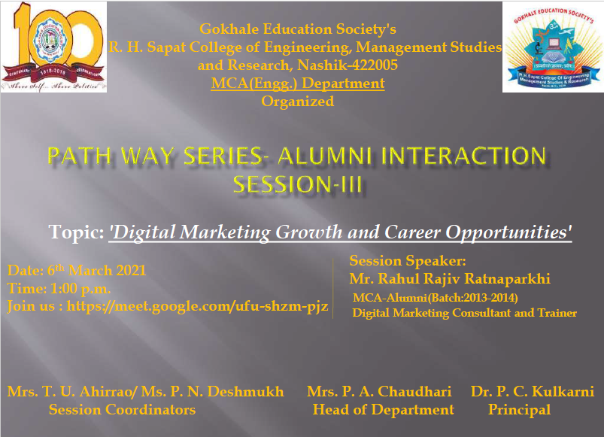
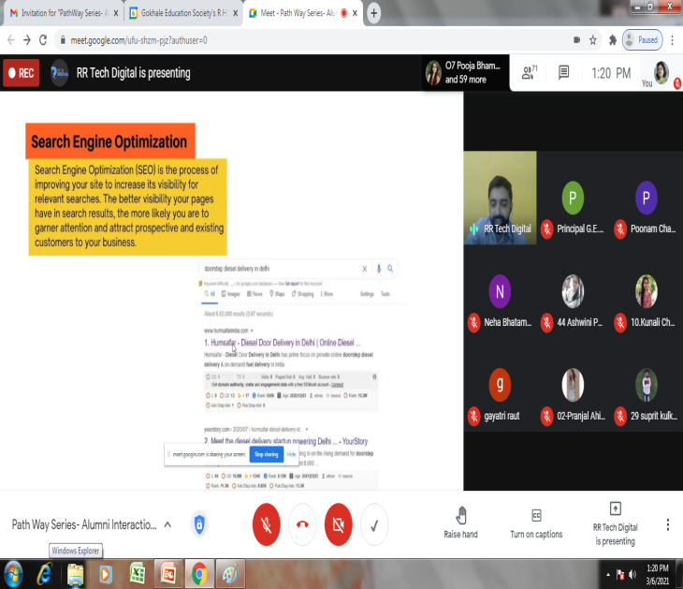
Mrs. T. U. Ahirrao
Prepared By

