Gokhle Education Society’s
- H. Sapat College of Engineering, Management Studies & Research, Nashik

Department of MCA(Engg)
Date: 8/2/2021

Report on
Induction Program 2021

MCA(Engg) Department organized An Induction Program for our newly admitted FYMCA students. Events details are as follows:
Date: 6th February, 2021
Time: 10.30AM to 4.15 PM
Venue: New Normal(Google meet)

Induction program was conducted to make the FYMCA students familiar with new teaching learning process, online platforms, Subject’s syllabub, examination scheme, teaching scheme etc.
Schedule was as follows:
Sr. No. | Subject Name | Staff Name | Time
1 | Object Oriented Programming & Lab | Prof. P. N. Deshmukh | 10.30 to 11.00
2 | Discrete Mathematics & Statistics | Prof. S. B. Kolpe | 11.15 to 11.45
3 | Data Structures & Algorithm & Lab | Prof. R. C. Samant | 12.00 to 12.30
4 | Software Engineering & Project Management | Prof. G. G. Raut | 1.30 to 2.00
5 | Information System Engineering Economics | Prof. S. B. Kolpe | 2.15 to 2.45
6 | Python Programming & Lab | Prof. G. G. Raut | 3.00 to 3.30
7 | Business Communication Lab | Prof. P. A. Chaudhari | 3.45 to 4.15

Every staff member took their respective sessions in given slot. As Prof. G. G. Raut was on leave on 6th Feb, she conducted her sessions on 8th Feb 2021.
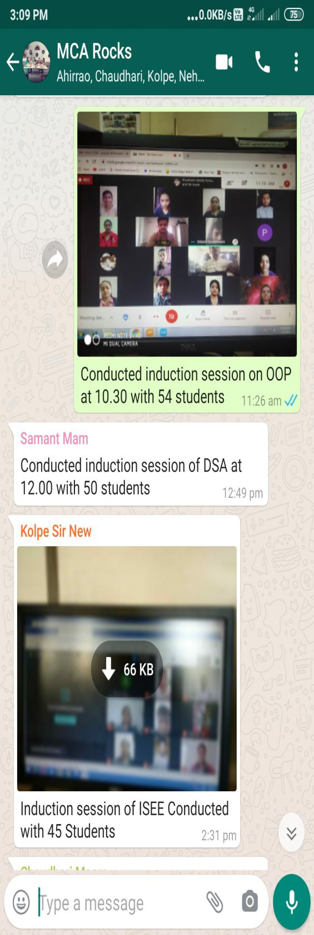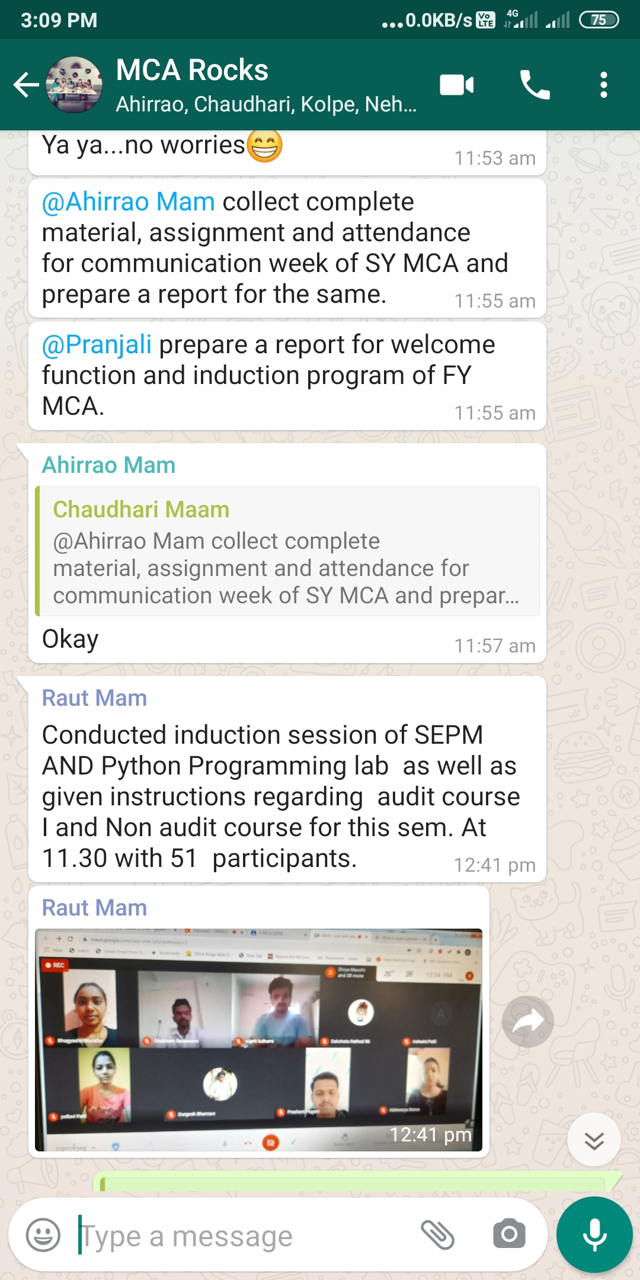

Prof. P. N. Deshmukh Prof. P. A. Chaudhari
Class coordinator(FYMCA) HOD

