Gokhle Education Society’s
- H. Sapat College of Engineering, Management Studies & Research, Nashik

Department of MCA(Engg)
Date: 8/2/2021

Report on
Welcome Function-” cin>>KnowUs>> 2020-21”

MCA(Engg) Department organized A Welcome function “ cin>>KnowUs>>2021”
for our newly admitted FYMCA students. Events details are as follows:
Date: 5th February, 2021
Time: 11.00AM
Venue: New Normal(Google meet)
Link: http://meet.google.com/hcv-iffx-ted
Event started at 11.00 on google meet for FYMCA students, Invitees, Staff members and SYMCA & TYMCA volunteers. Other SY & TY students joined the program through youtube stream link.(https://youtu.be/FRIkF695Xms)
For the program, honourable Principal Dr. P. C. Kulkarni was present as chief guest. Mr. Ankush and Ms. Pallavi(TYMCA) started the event with formal anchoring. Pallavi sung Sarswati Vandana in her melodious voice. Then Harshal(TYMCA) delivered a welcome speech for his juniors. Principal sir addressed the audience by giving his valuable advice to the freshers. Then, Prof. P. A. Chaudhari (HOD-MCA Dept) introduced the MCA course along with Society, College & department in detail with the help of ppt. All the staff members of MCA department (Prof. R. C. Samant, Prof. T. U. Ahirrao, Prof. G. G. Raut, Prof. P. N. Deshmukh, Prof. N. V. Bhatambarekar, Prof. S. B. Kolape)also had interaction with the the new faces. With this formal program ended.
Then informal part started, it was fun activity, games & performances. Harshal(TYMCA) performed various friendship songs on guitar and tried to make the freshers comfortable. Then Game- 1 (Guess the song from emojis)was conducted by Shital & Nayonika(TYMCA). Game-2 (Collect things from alphabets) was conducted by Pranali & Vidya(SYMCA). In between the games, Freshers also introduced them. Then Shradhha(SYMCA) sung a beautiful fusion of old songs to say Welcome again. At the end, Prof. P. N. Deshmukh delivered a Vote a Thanks.
The event was successfully handled by SYMCA & TYMCA coordinators.

Event Poster: Technical Setup:

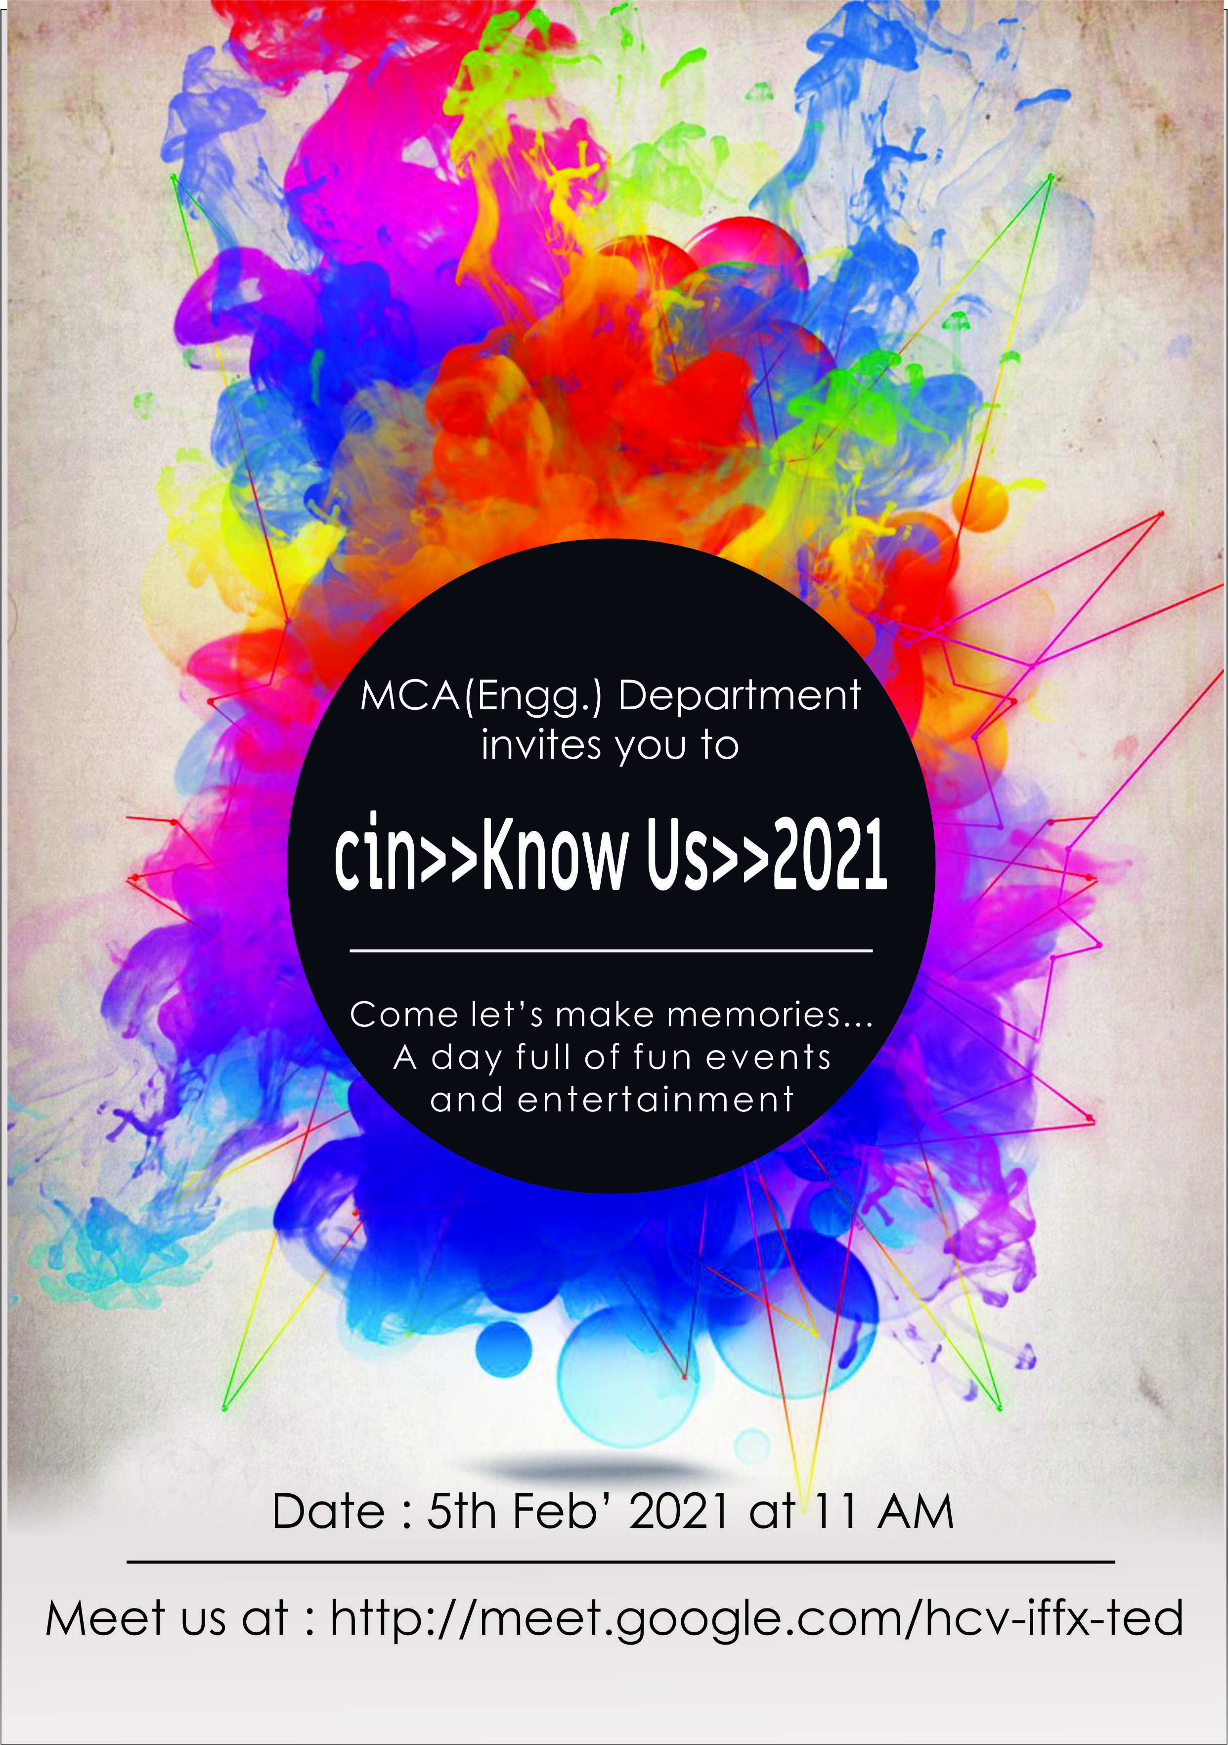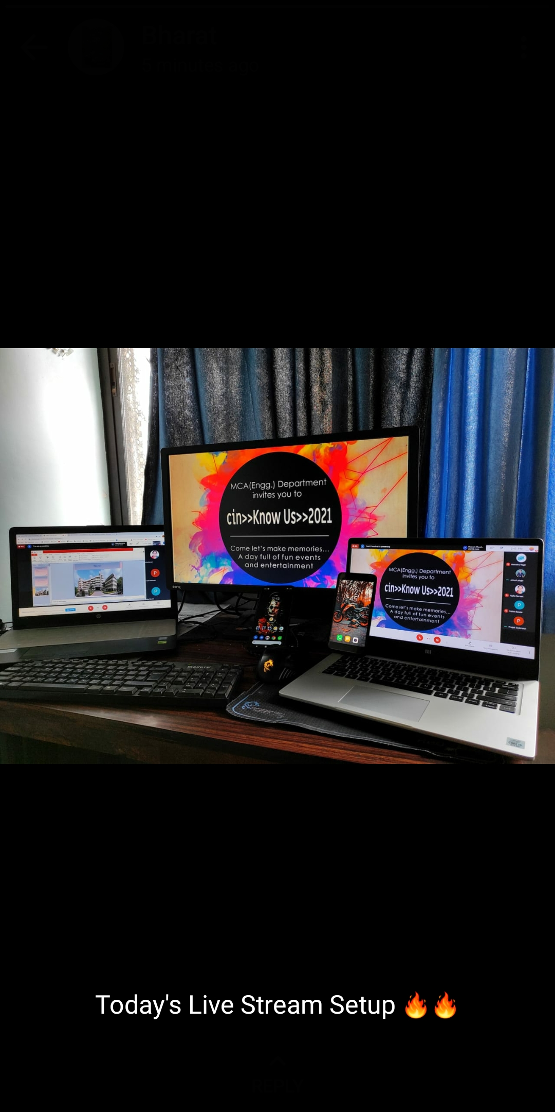

Activities:
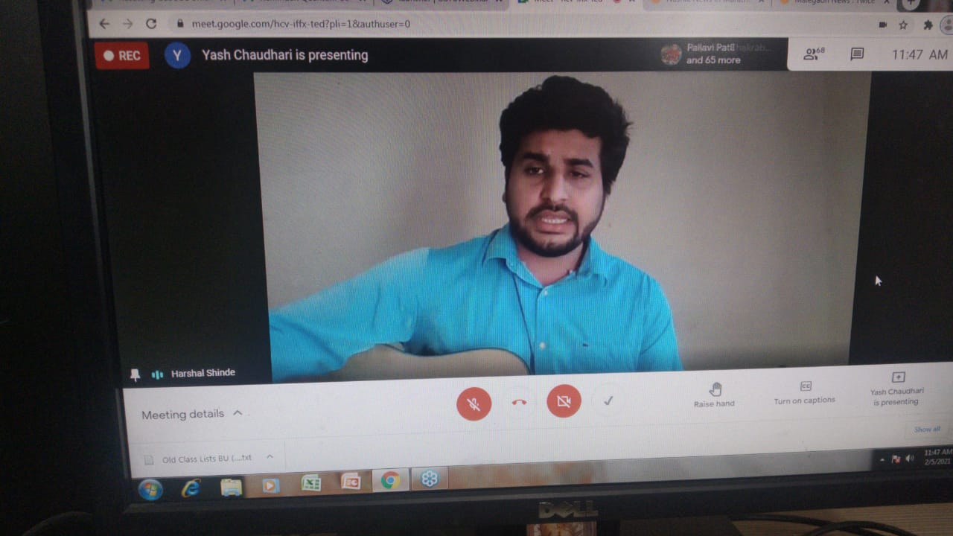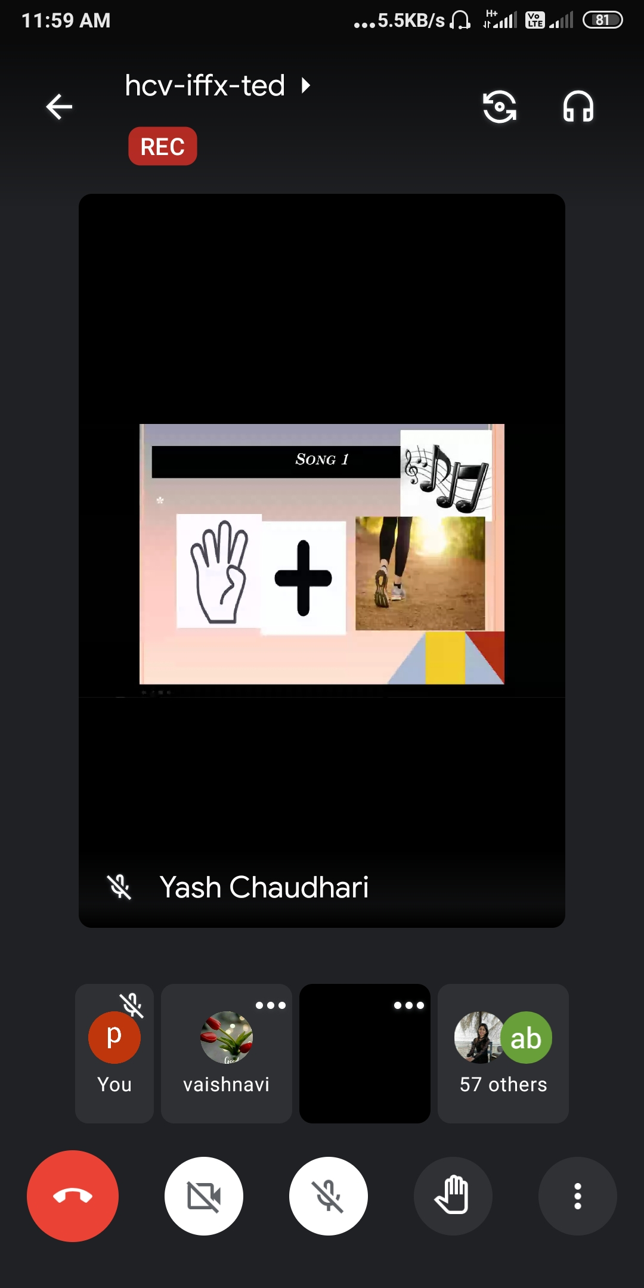

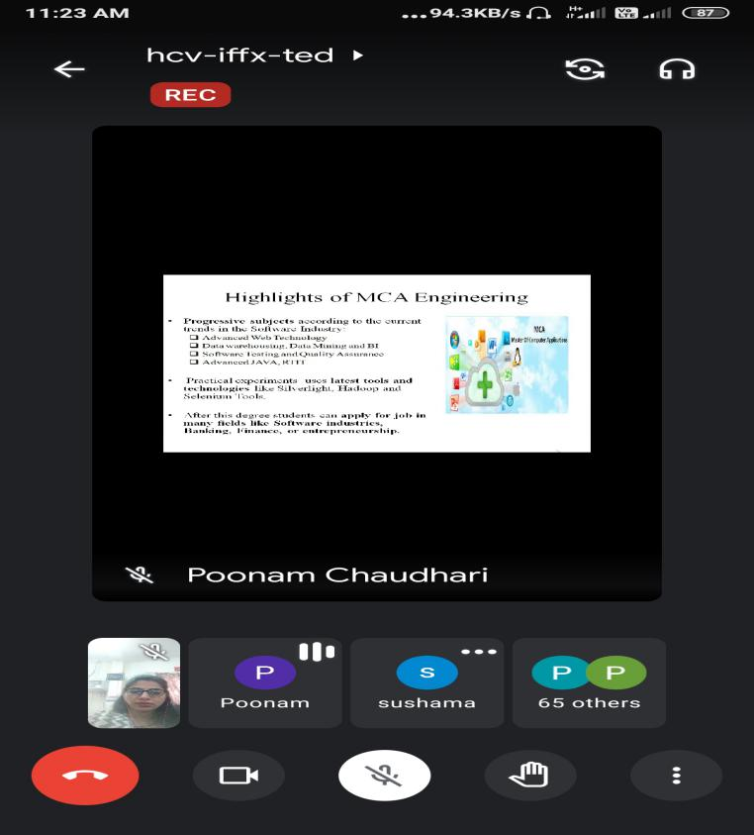

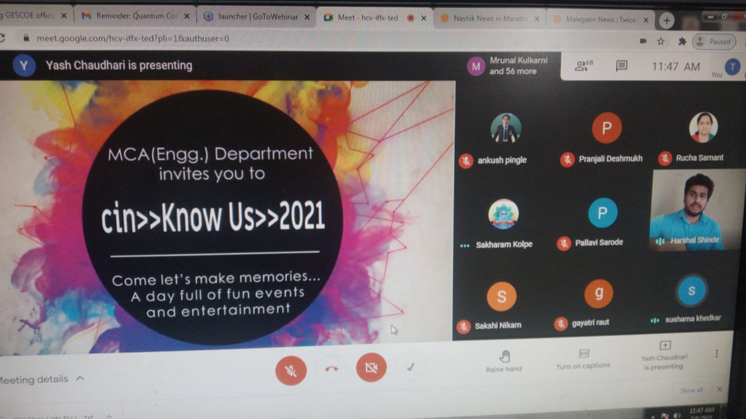

Prof. P. N. Deshmukh Prof. P. A. Chaudhari
Class coordinator(FYMCA) HOD

